
AMERICAN INTERNATIONAL UNIVERSITY-BANGLADESH
Faculty of Science and Technology
Department of Computer Science
CSC 3215: Web Technologies

Semester: Summer 2025-26 | Group No: 06 |  | Section: | L

Group Members:
SL. | Student ID | Name | Role | Signature
1 | 23-51688-2 | Rayhan Bin Maleque | Group Leader
2 | 23-51692-2 | Piyal Saha | Member
3 | 23-51708-2 | Durjoy Saha | Member
4 | 23-51105-1 | Md. Abdul Alim | Member
Project Title
Campus Event Management System
Short Description
The Campus Event Management System is a web-based platform designed to manage university events efficiently. The system allows students to discover and register for events, organizers to create and manage events, staff members to manage attendance and verify tickets, and administrators to control users, approve events, and monitor system activities.
The system provides authentication, role-based dashboards, event management, registration, payment tracking, digital ticket generation, QR-based attendance verification, and activity monitoring.
Introduction
Managing campus events manually is time-consuming and difficult because event registration, participant tracking, attendance management, and payment records require proper coordination.
The Campus Event Management System solves these problems by providing a centralized online platform where different users can perform their assigned tasks according to their roles.
The system contains four types of users:
- Admin
- Organizer
- Student
- Staff
Each user has a separate dashboard and specific functionalities.
Background Study
In many universities, event management activities are handled manually using paper forms, spreadsheets, and separate communication platforms. These methods create problems such as:
- Difficulty managing participant information
- Lack of real-time attendance tracking
- Manual payment record maintenance
- Poor communication between organizers and students
- Difficulty monitoring event activities
A web-based event management system can automate these processes and improve efficiency.
This project uses:
- PHP for backend development
- MySQL database for data storage
- HTML, CSS, JavaScript for frontend
- AJAX for dynamic searching
- Session and cookie-based authentication
ER Diagram
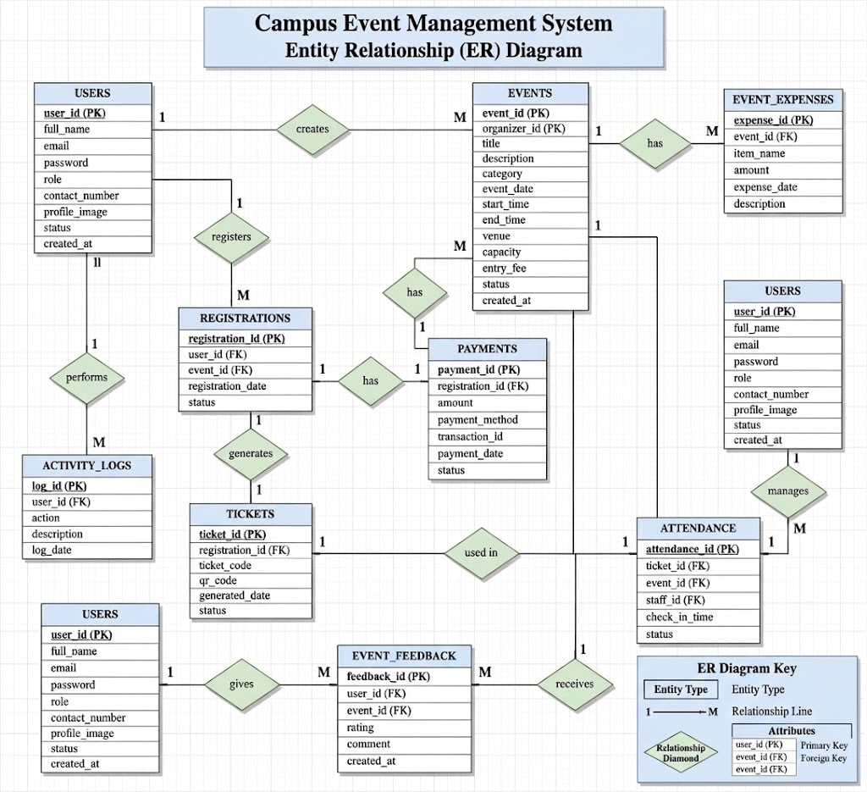

Use Case Diagram
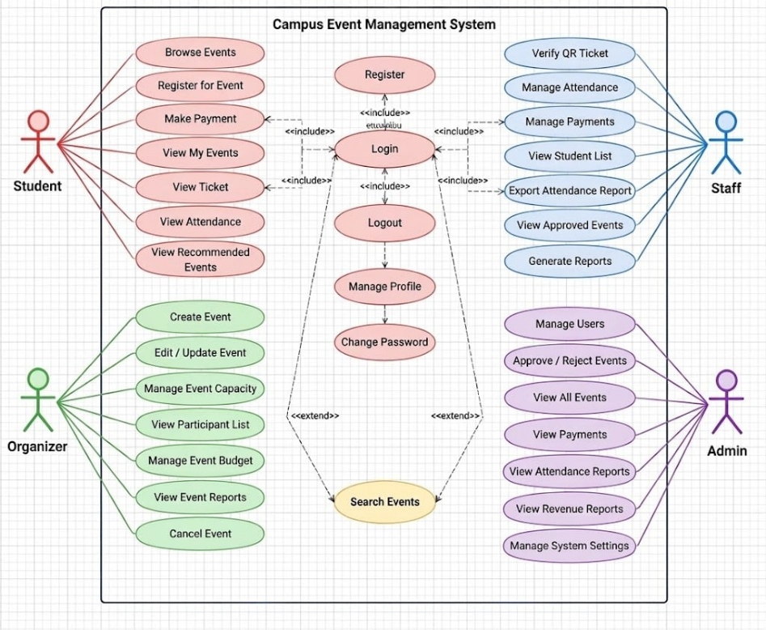

UI (Figma/Sketch)

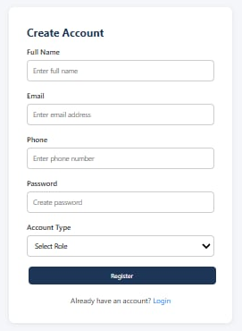
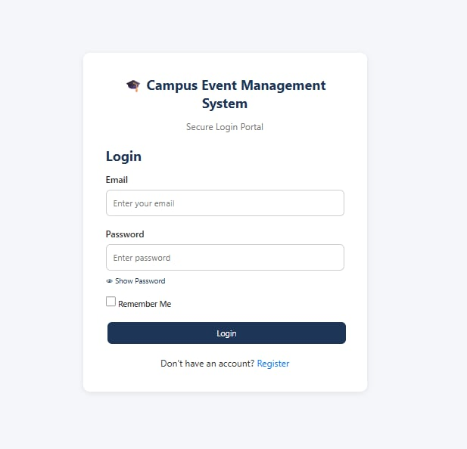

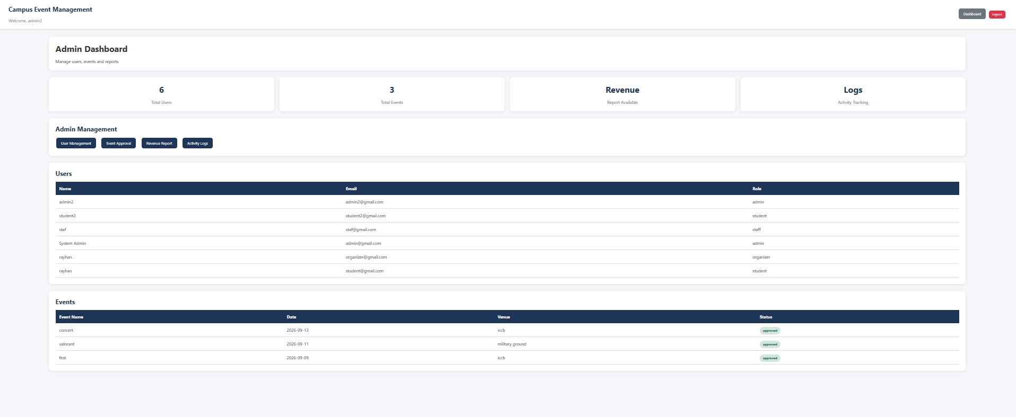

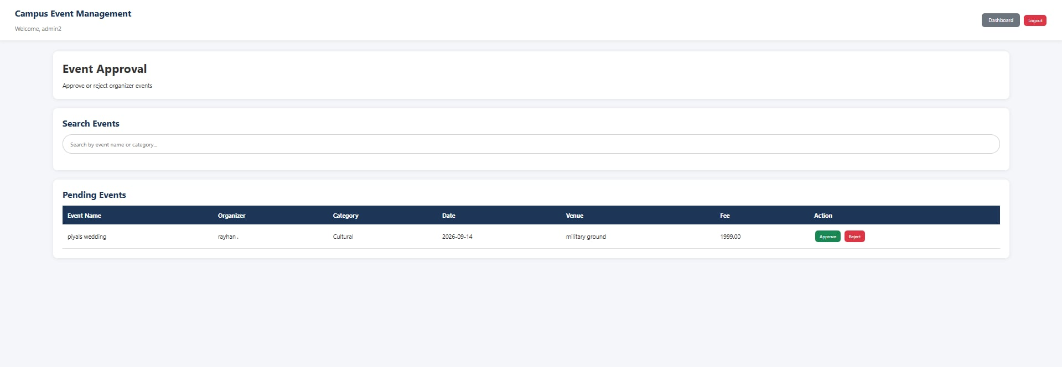

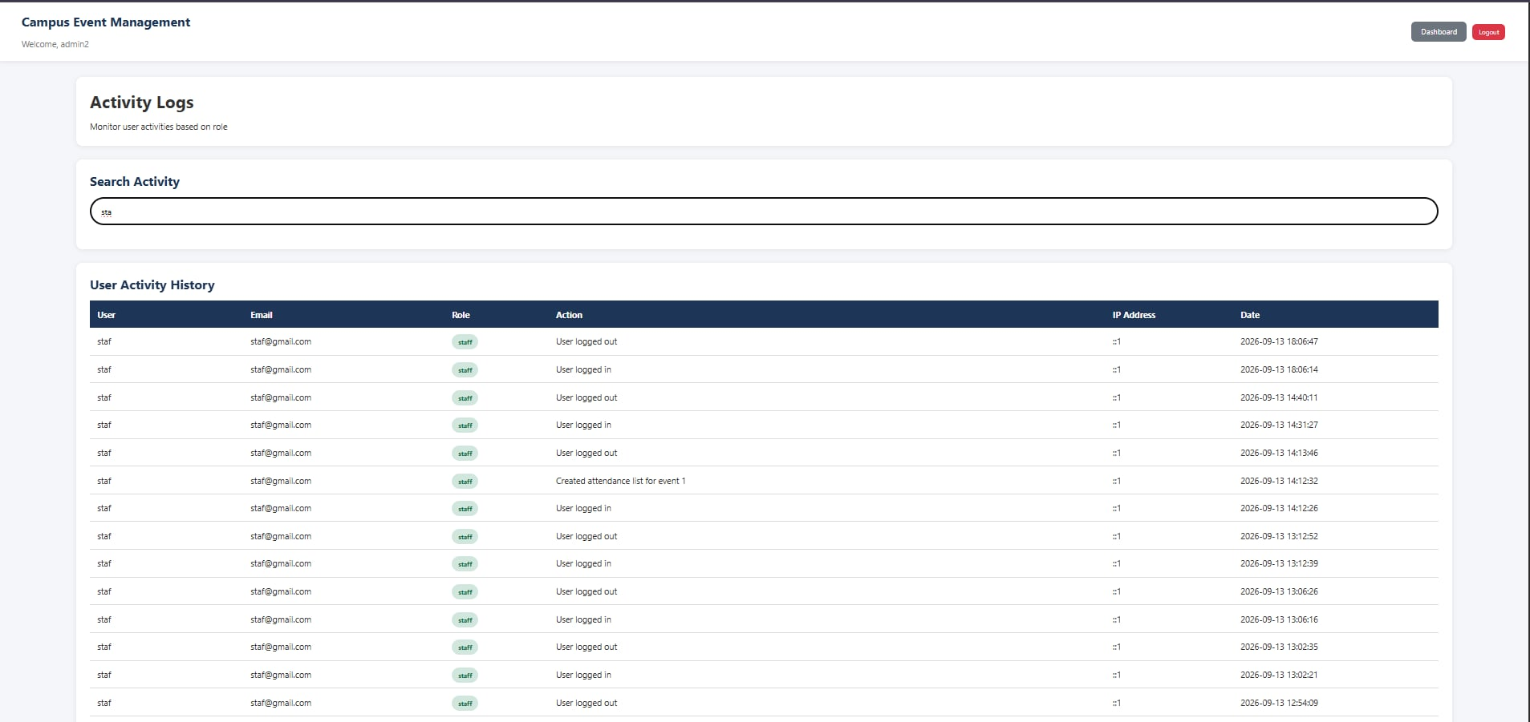

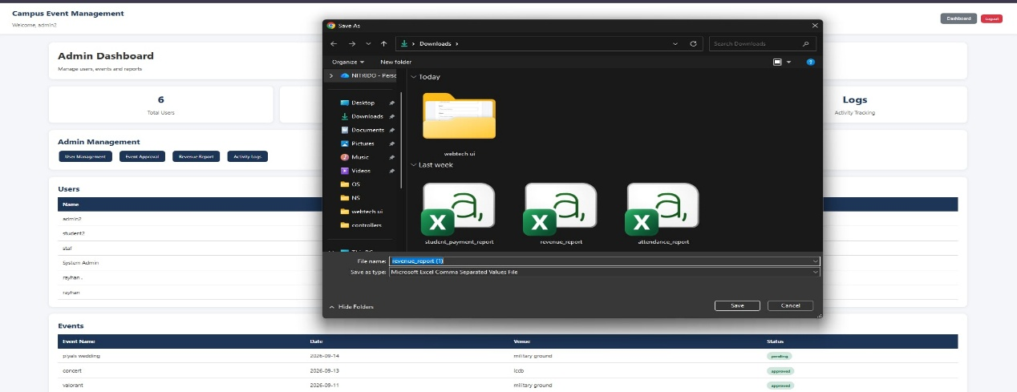

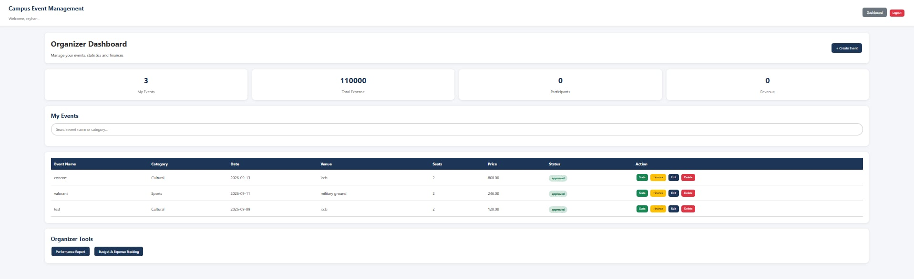

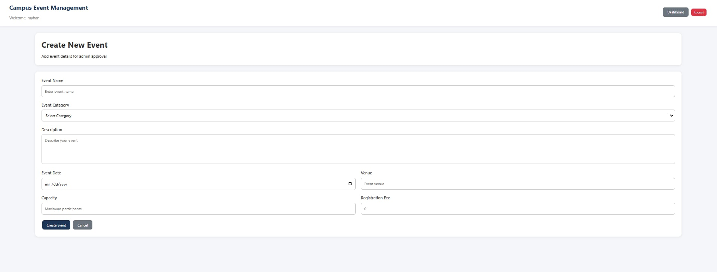

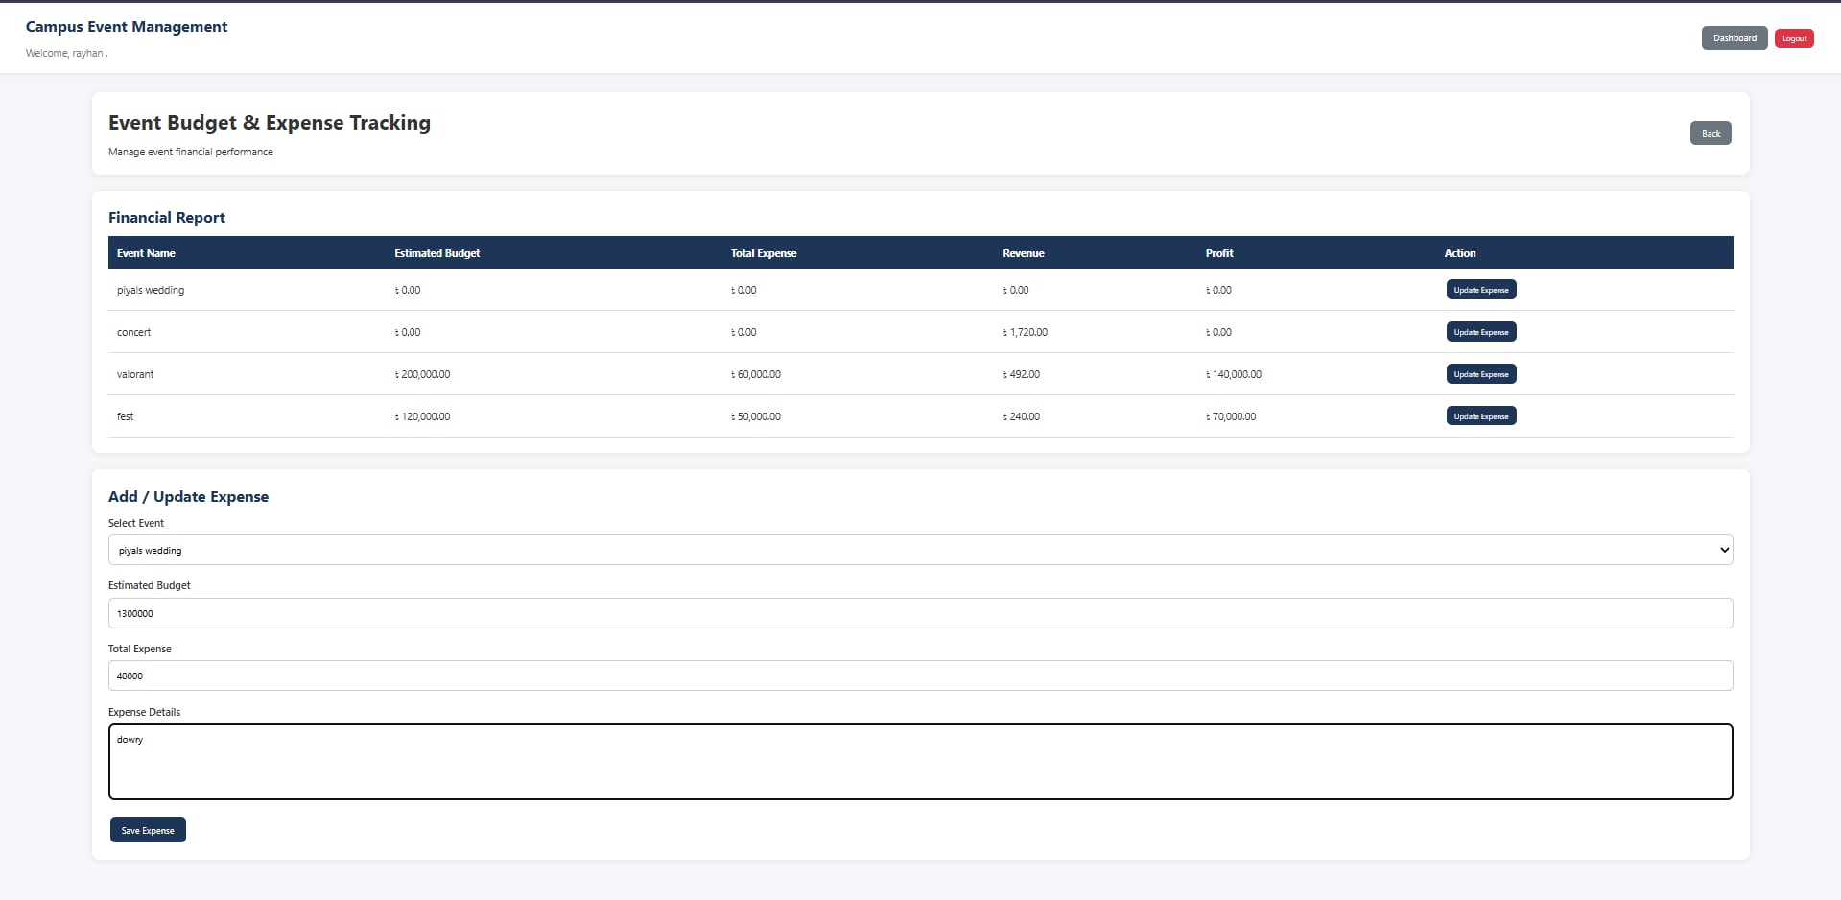

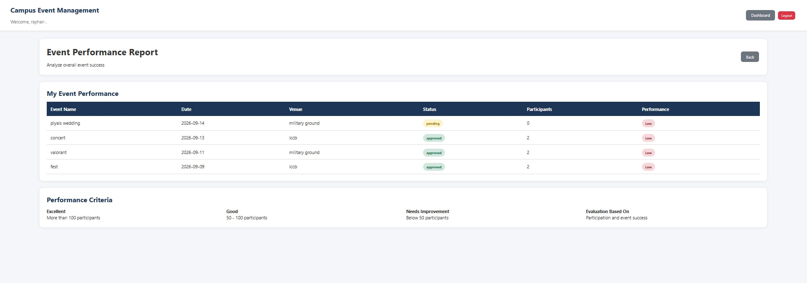

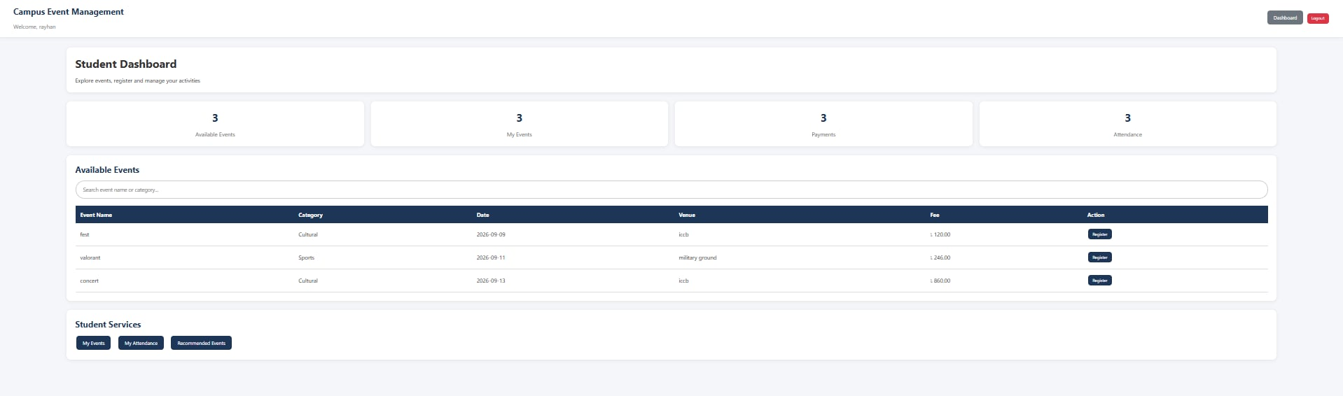

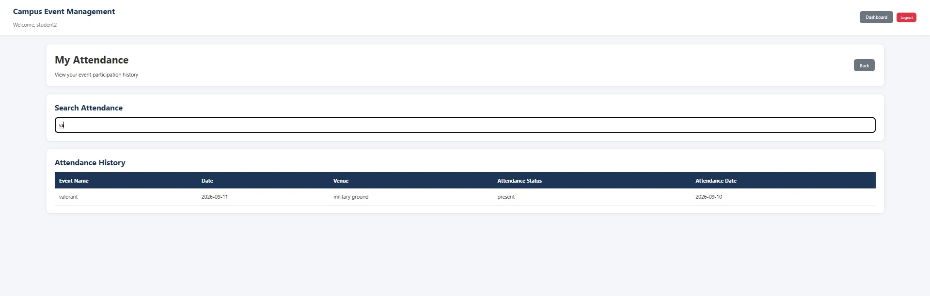

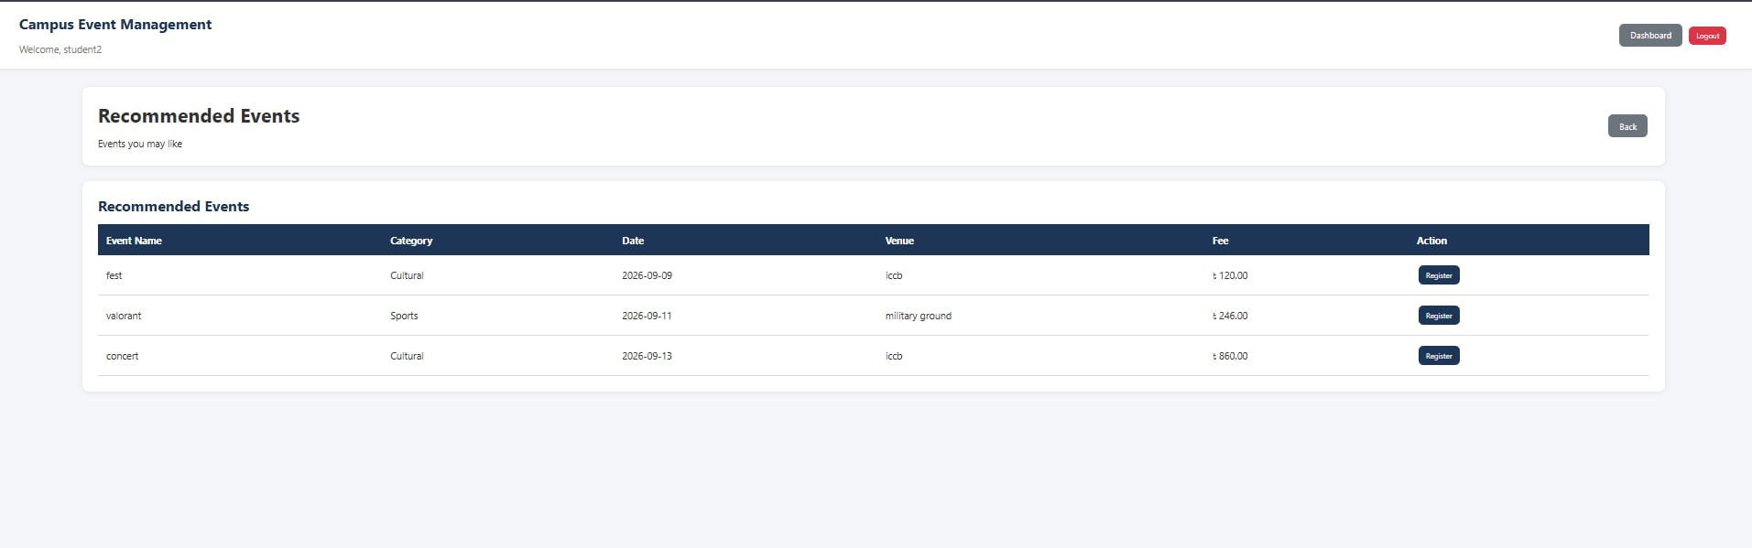

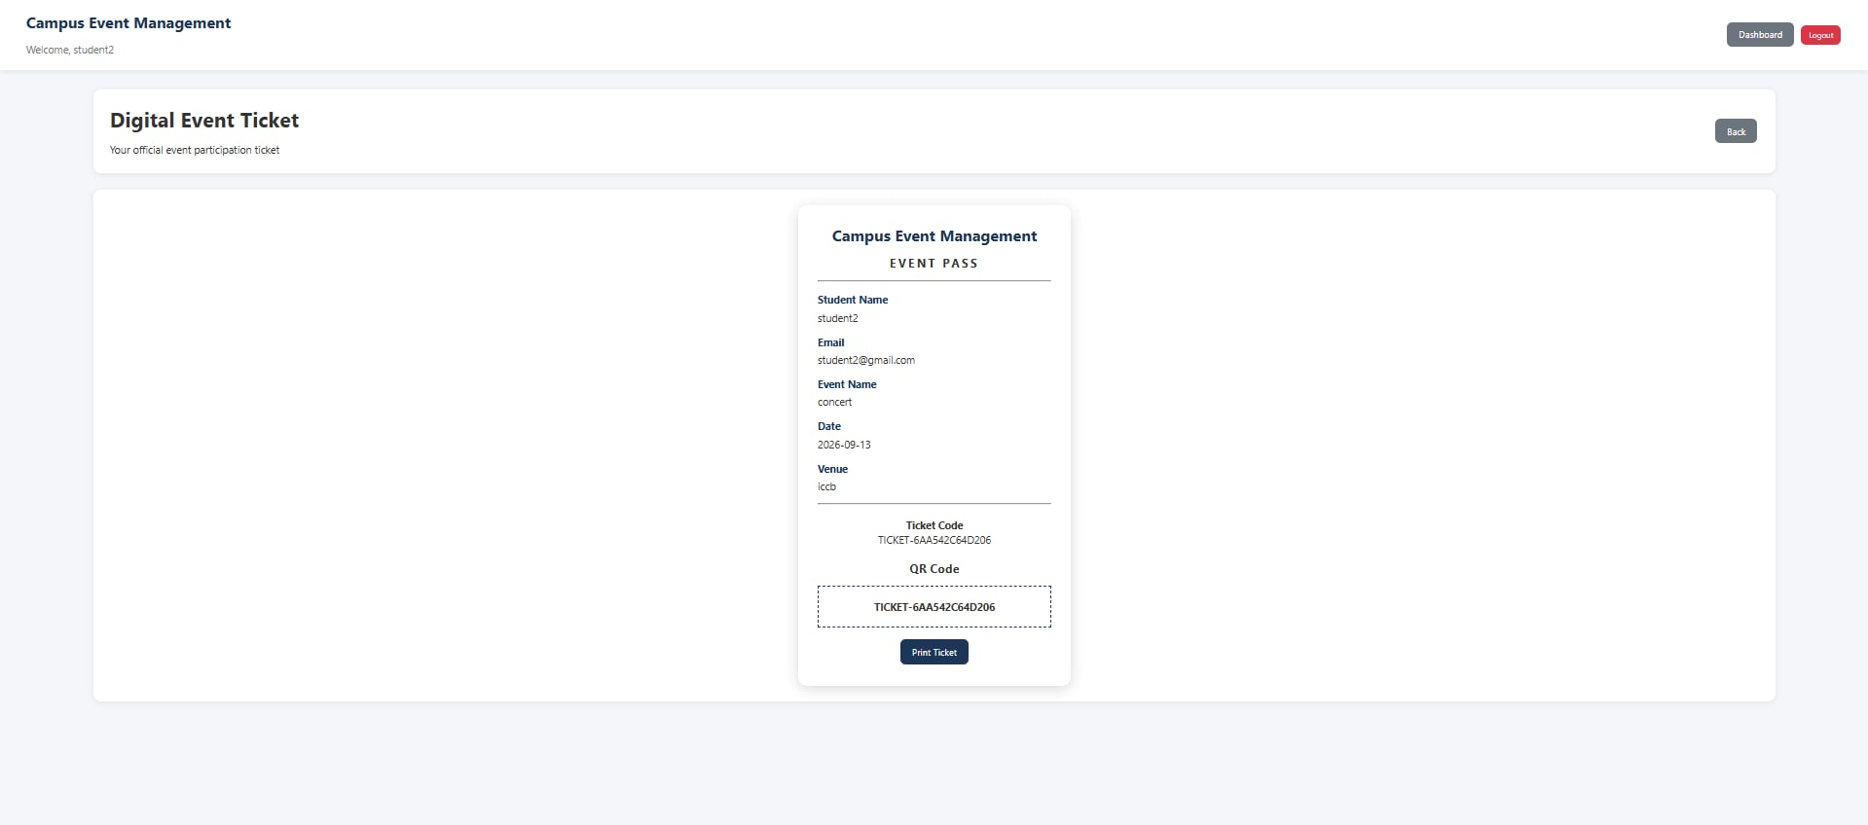

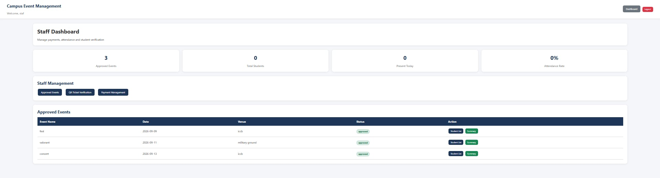

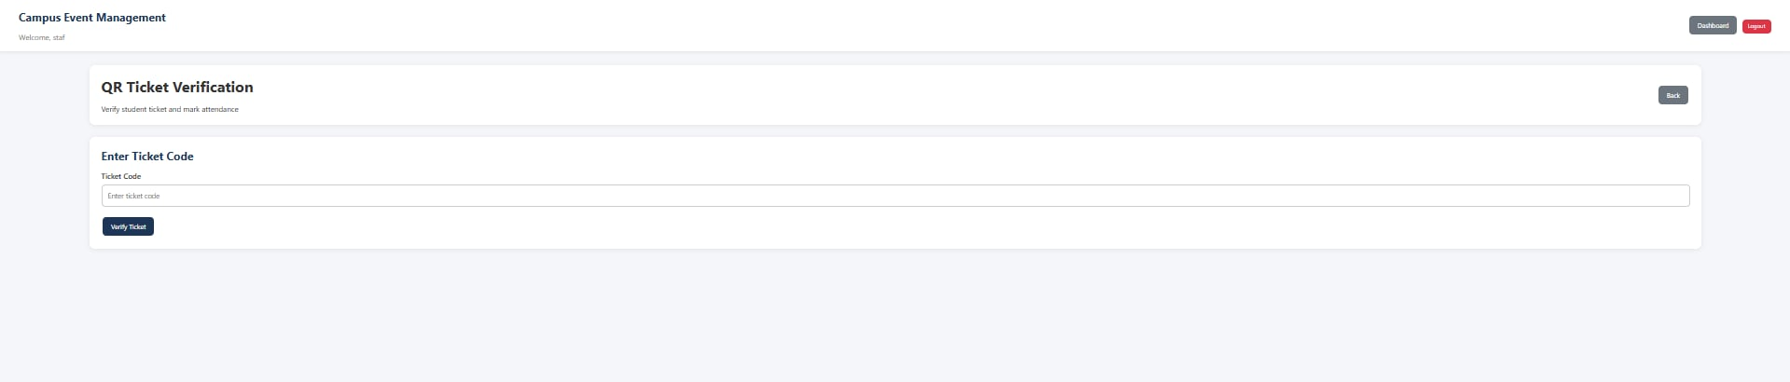

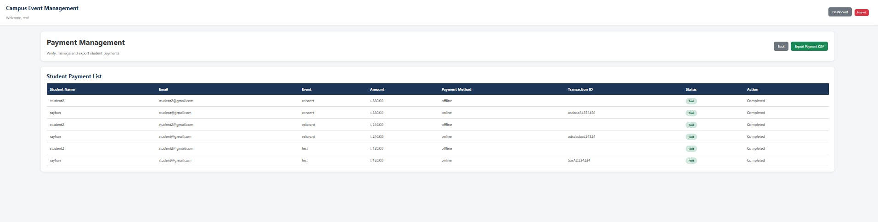

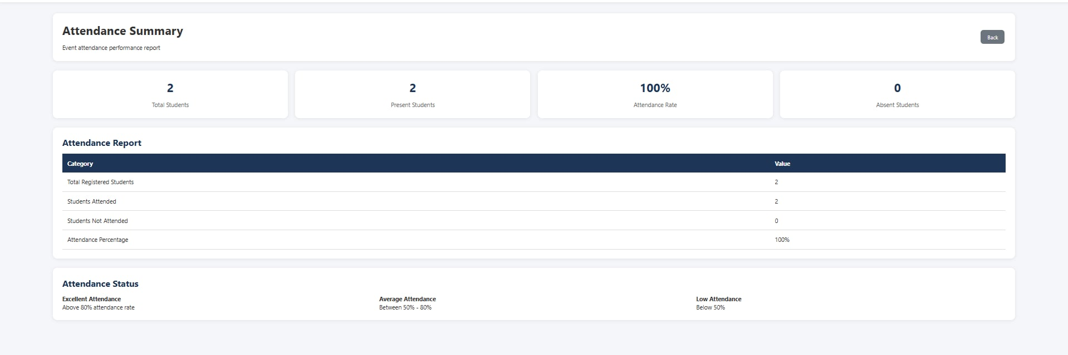
Types of Users: 1. Admin 2. Organizer 3. Student 4. Staff
Common Features (Available to All Users)
- Authentication
- Login to the system
- Logout from the system
- User registration
- Account Management
- Change or reset password
- Manage profile information (view, edit, delete)
- Dashboard
- Access a personalized dashboard after login
Specific Features by User Type
- Features of Admin
- Event approval management
- Activity monitoring
- Revenue reports
- Features of Organizer
- Create new events
- Finance Management
- Monitor event performance
- Features of Student
- Event recommendation
- Event pass (Digital Ticket)
- Attended Events
- Features of Staff
- Ticket verification
- Payment management
- Event summary and student list

